 Bournea Reaching Out

Historical Walk
A walk or stroll in the Parish of Bournea West, taking in places of interest with a historic, folklore and cultural theme.
Starting point Clonakenny village at the Nore Brook Lounge and finishing at the Burnt House Borrisnoe
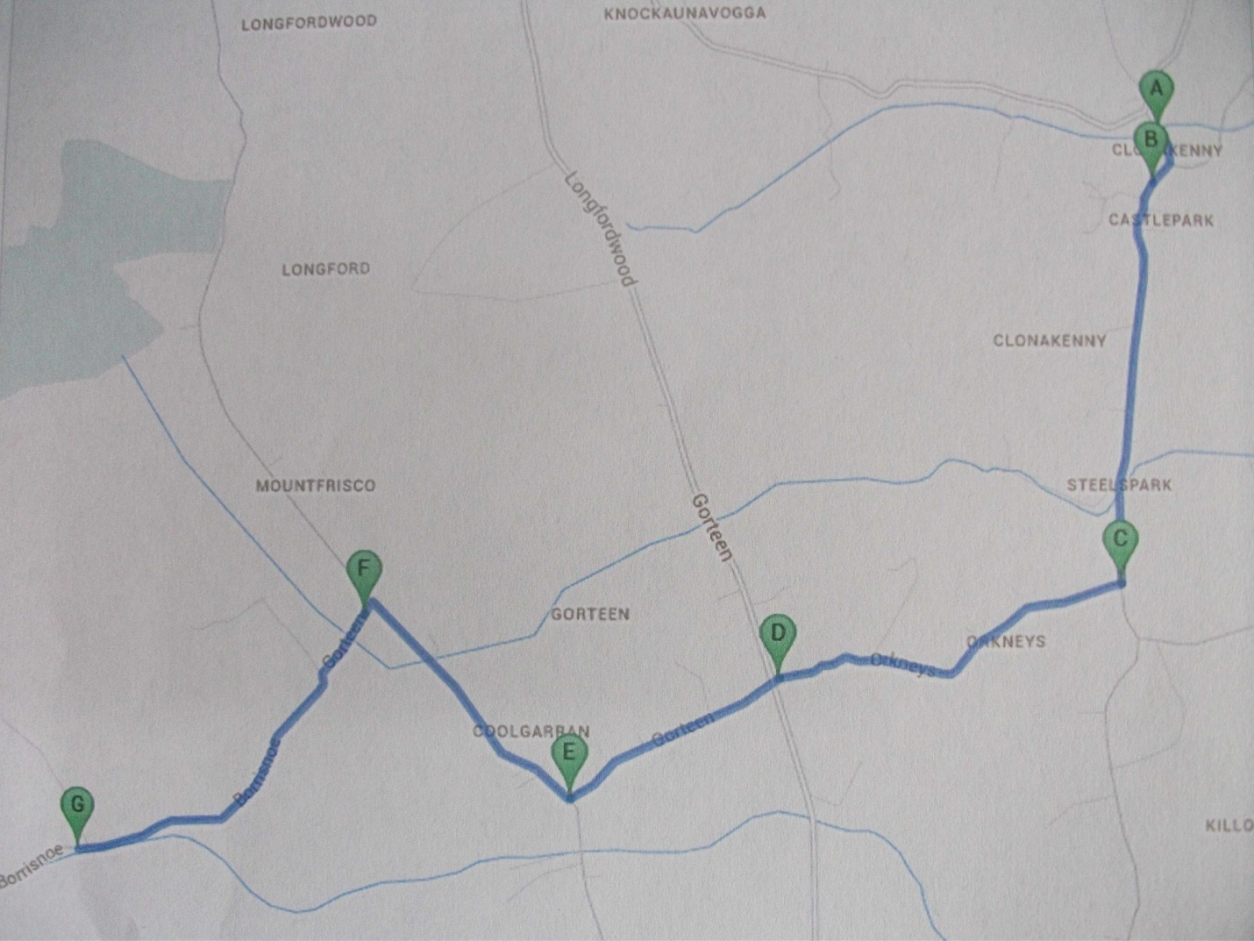
Follow Route on Map A to G - Tour Guide Jim Kennedy
On Sunday 6th of October 2013 Starting 1.30

A) Clonakenny Roman Catholic Church and Graveyard
1) The O’Meagher Castle
2) The Church in the Park
3) The Old Thatched Village
4) The Post Office
5) The Forge
B) The Irrigation Channel
1) The Tan Hole – Steel Park
2) The Standing Stone and Ringforts in Castle Park
C) Delaunthy’s Cross
1) Parish Boundary
2) The Orkneys
D) Gurteen Cross
1) The Coach Road
2) The Mile Stones
E) Doyle’s Cross
1) Coolgarran
2) Garret Mill
3) The Lime Kilns
4) The Suir Bridge
F) Frisco Corner
1) Mountfrisco
2) The Lloyd’s
3) The Ancient Well
G) The Burnt House
1) The Wall Oven
2) The Flax Mill

